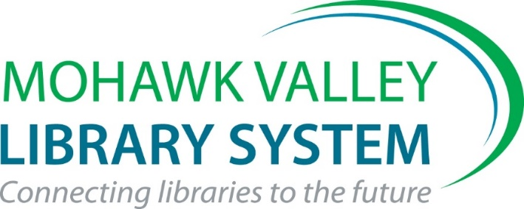

Harold and Junice Wusterbarth
Volunteer Service Award
2022 Nomination Form

Framed Certificate + $500 for Library Materials Identified by Bookplate(s)

Please answer the following 3 questions using this form. Make your answers descriptive and concise as you describe the contributions made to foster library services in your community. This written part of the application should be no more than 2 pages total. Please focus on activities that took place over the last 3 years.

You may add up to 2 additional pages of support materials – photos, publicity materials, news stories, etc. The application package may not exceed 4 pages total.

Staff members of individual libraries and of the MVLS are ineligible for consideration

I nominate affiliated with the

Library, for the MVLS Volunteer Service Award

Submitted by_______________________________________________
Submit nomination via email to kclingan@mvls.info by Friday, September 2, 2022

- What was the focus of this volunteer effort and why were these activities important to your library?

- Where and when did the volunteer activities and services take place?

- How did your library/community benefit from this volunteer effort? How was it successful?

Return via email to Kate Clingan at kclingan@mvls.info by
Friday, September 2, 2022

