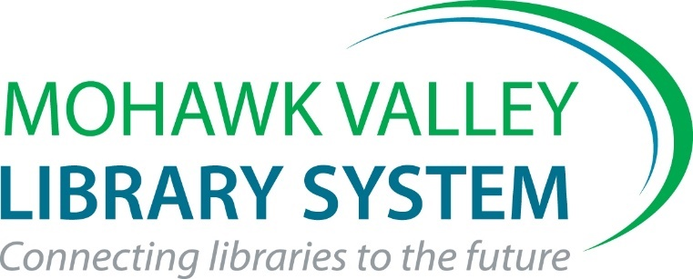

Library Recognition Award

2023 Nomination Form

Please answer the following 3 questions using this form. Make your answers descriptive and concise. Sell your project or service! This written part of the application should be no more than 2 pages total. You may add up to 2 additional pages of support materials – photos, publicity materials, news stories, etc. The overall application package may not exceed 4 pages total.

I nominate the ________________________________________________Library for the

2023 MVLS Library Recognition Award.

Project Title:

Submitted by: _______________________________ Library____________________
Submit nomination via email to kclingan@mvls.info by Friday, September 1, 2023

- Describe what you did. Where and when did activities & services take place? Who were your partners?

- What community need did your project address? Why did you develop this activity or service?

- Describe how this project or service made a difference in your community using statistics, stories & photos. Who benefited and how did they benefit? Will you continue this activity or service? Why?

Return via email to Kate Clingan at kclingan@mvls.info by
Friday, September 1, 2023

