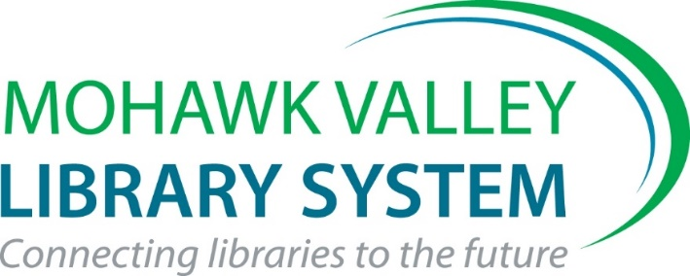

Mohawk Valley Library System
Outstanding Library Staff Award
2023 Nomination Form

Framed Certificate + $500 for Library Materials Identified by Bookplate(s)

Please answer the following 3 questions using this form. Make your answers descriptive and concise as you describe the contributions made to foster library services in your community. This written part of the application should be no more than 2 pages total. Please focus on activities that took place over the last 3 years.

You may add up to 2 additional pages of support materials – photos, publicity materials, news stories, etc. The application package may not exceed 4 pages total.

The award is open to any paid employee at an MVLS library. It is awarded to library staff, not library directors.

I nominate affiliated with the

Library, for the MVLS Outstanding Library Staff Award

Submitted by_______________________________________________
Submit nomination via email to kclingan@mvls.info by Friday, September 1, 2023

- Please describe this staff member’s history at your library.

- What, specifically, did the nominee do to earn your nomination? Where and when did the activities and services take place?

- How did your library/community benefit from this effort? How was it successful?

Return via email to Kate Clingan at kclingan@mvls.info by
Friday, September 1, 2023

